Work Order Request Directions for MPulse 9

The new facilities maintenance software update new version MPulse9. This system will allow work order requests to be done via the world wide web.

The link to the sign on is: <https://www.mpulse9.com/#/> (put mouse over link, hold Ctrl and click)

This link will take you to the logon screen:

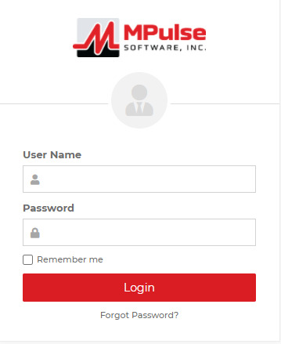



Please save this under your favorites for Internet Explorer, bookmarks for Chrome and Firefox. User Name = requester@micaonline.org, Password = happy, then hit  .

The screen will open up and look like this (it retains the last work request sent) or it may be blank because ones submitted have been approved and turned into Work Orders, the screen is called Maintenance Request Records. **Please note you will have to do a work order for each thing. You cannot put four (4) requests on one work order. This system has to track each thing individually. To store furniture and move you will have to do the furniture and storage form request that is found on P:/Facilities Forms/Storage Policy and Furniture forms. You will still have to fill it out and send it as attachment by email to your Program Director and Terri Tague for approval first. Once it has been approved by all then we will put it on a work order. If there is a specific date it has to be done by please include the information in the email.**



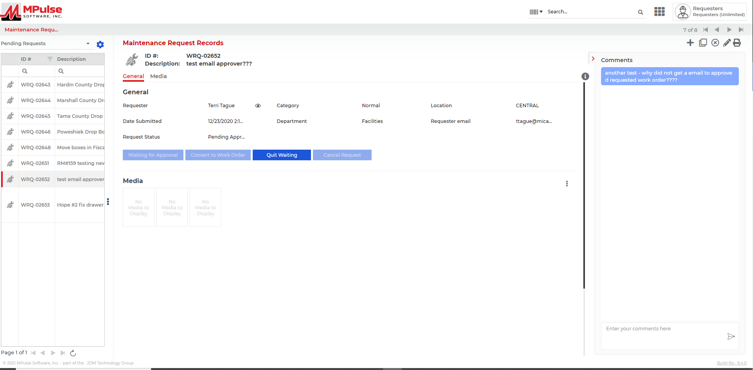



Do not try to type over one in the screen!! Always click + sign to start a new Work Order Request in the upper right hand corner!! **Please allow the time to put in the work order request, it will not allow you to logout till this work order is completed. If you do not logout this will prevent someone else from being able to login, create and submit a work order request. Please contact Connie Thomsen and/or Terri Tague if you have any problems.**



Otherwise the screen will look like below after click  and you are ready to start your request:

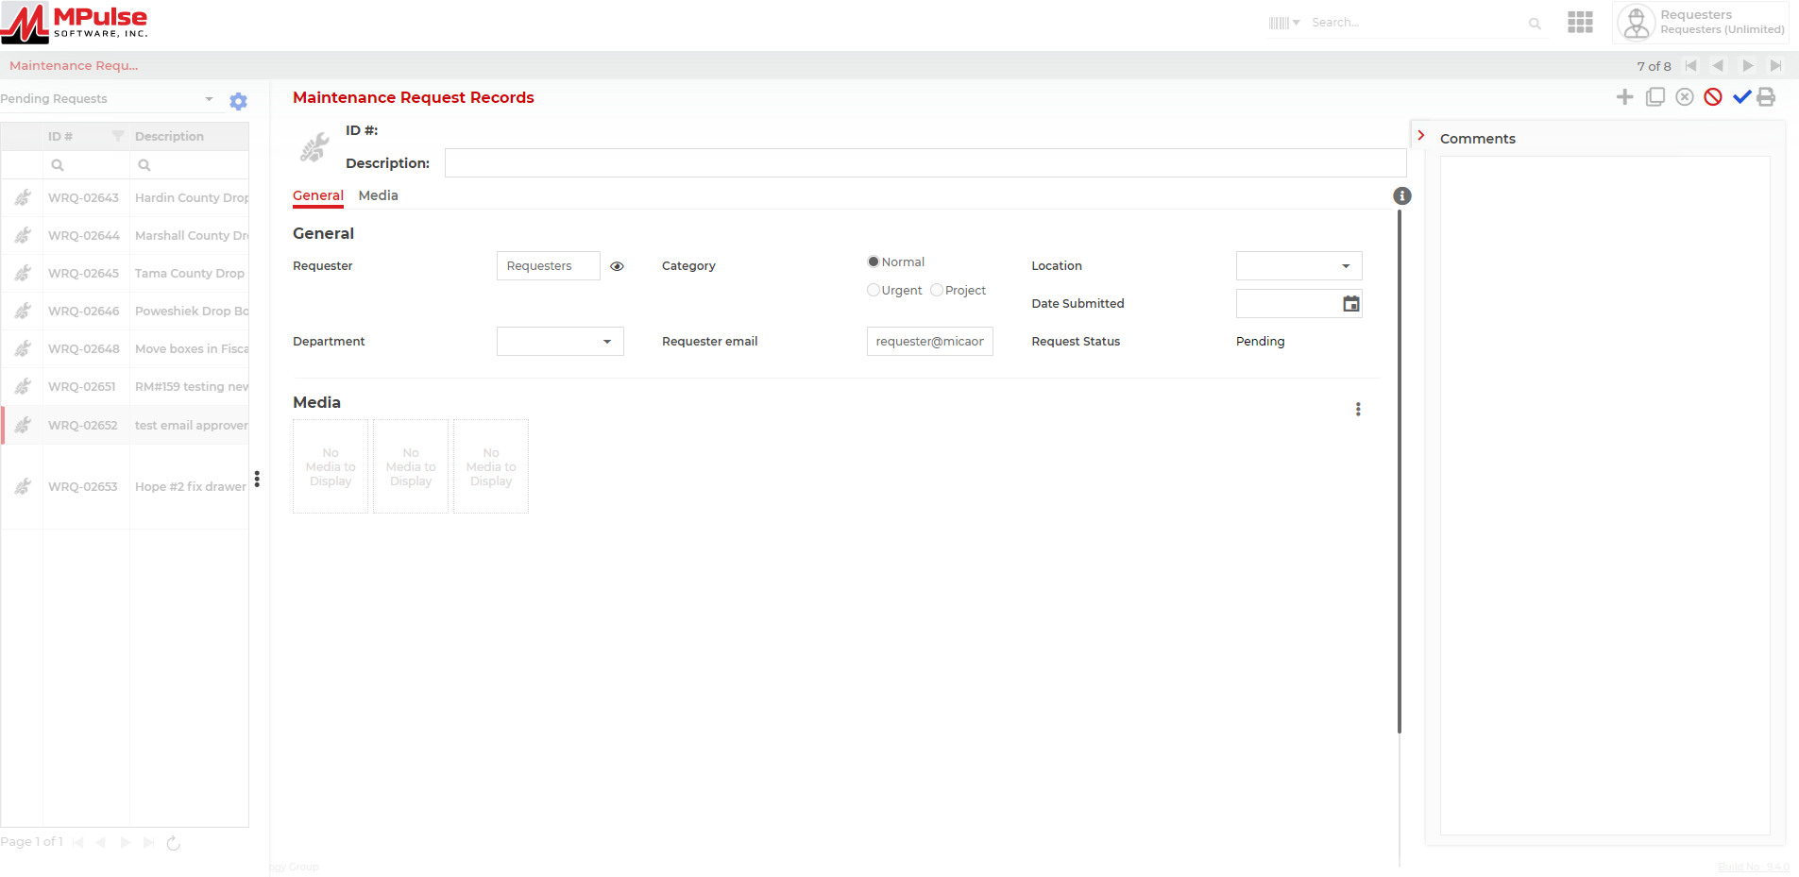



1. In Description box type brief description of requested work ex: Office #160 fix desk drawer:



2. In Requester box delete the name “Requesters” and type your name in ex: John Doe



3. In Category area it will default to Normal you do not need to do anything unless it is Urgent click in the circle in front of Urgent to select. 

4. In Location box click on drop down menu and pick your location ex: Central 







So far this is what it should look like ☺

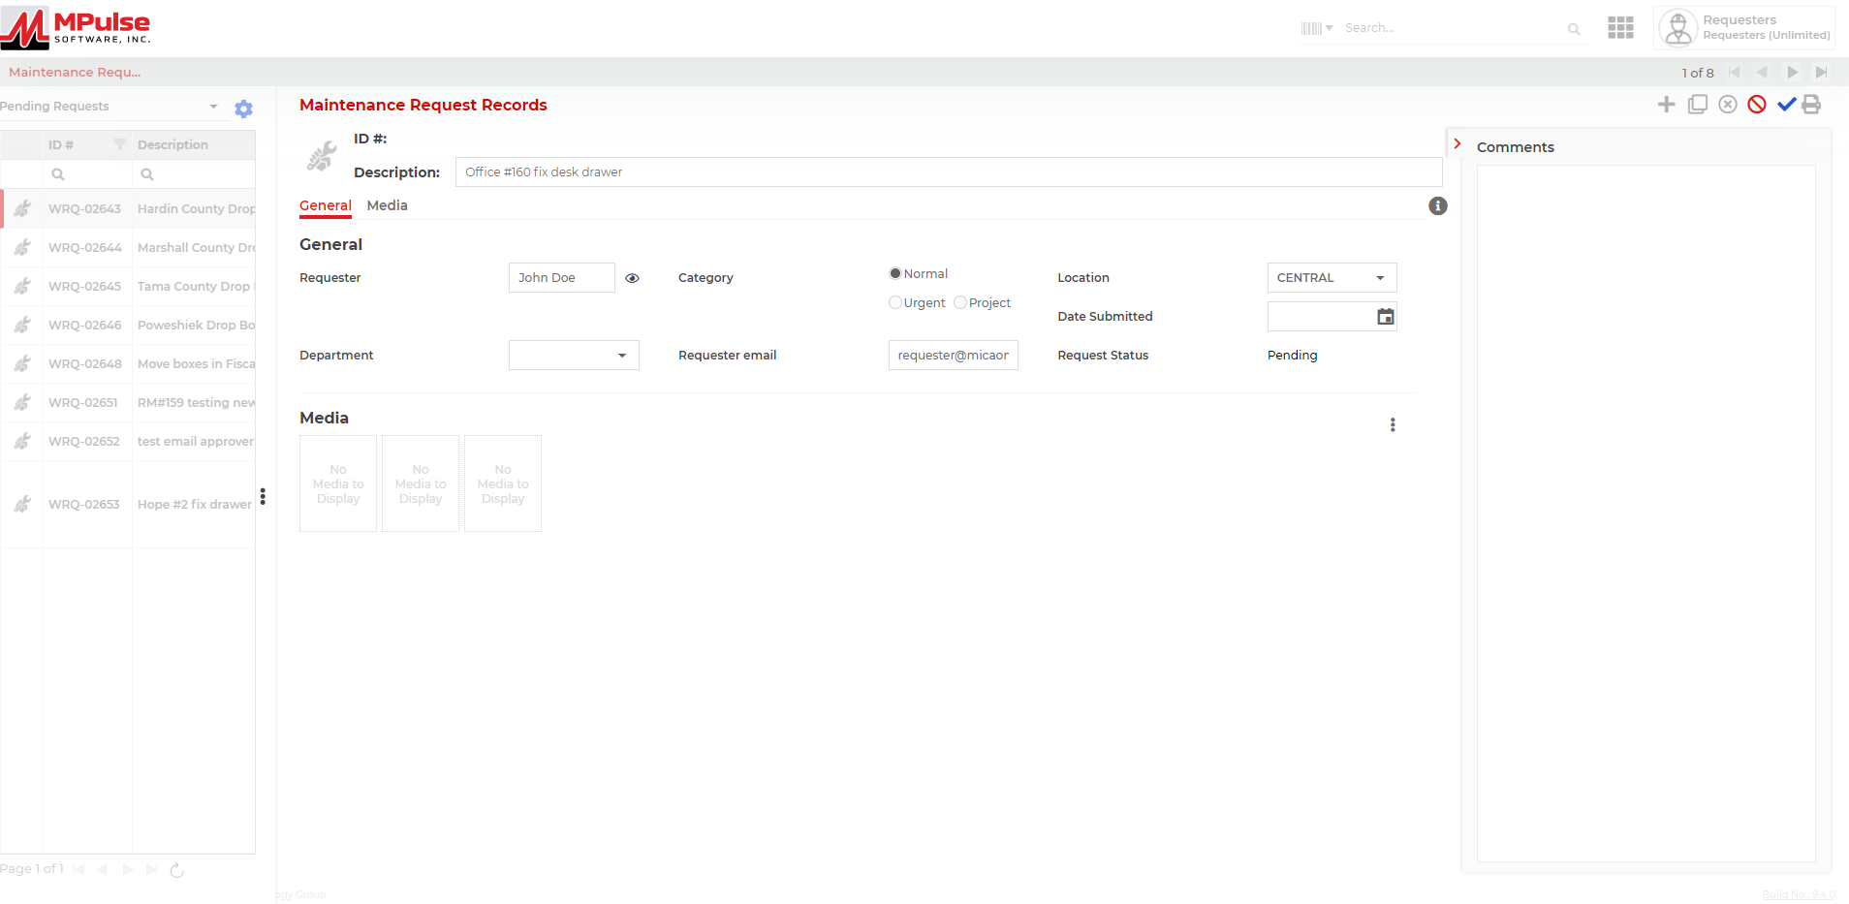

5. In Date Submitted don’t do anything-it will generate once you submit the request: 

6. In Department:  click on pop down arrow in box Choose your Department – these are your choices 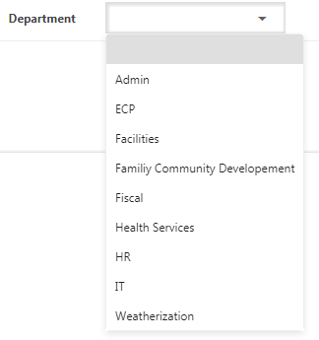

******Department generates which Director needs to approve the request. Who is your Director?

Clarissa T = Admin Carrie S = ECP Terri T = Facilities & Weatherization

Allison W = Family & Community Development Amanda Mc = Fiscal & IT Megan T = Health Programs (not including WIC) Sierra S = WIC Rachel P = HR

7. In Requester email delete [requester@micaonline.org](mailto:requester@micaonline.org) and enter your email:



8. In Request Status will remain Pending until the work order has been approved and turned into an

actual work order. Do nothing ☺ 





So far this is how it should look ☺



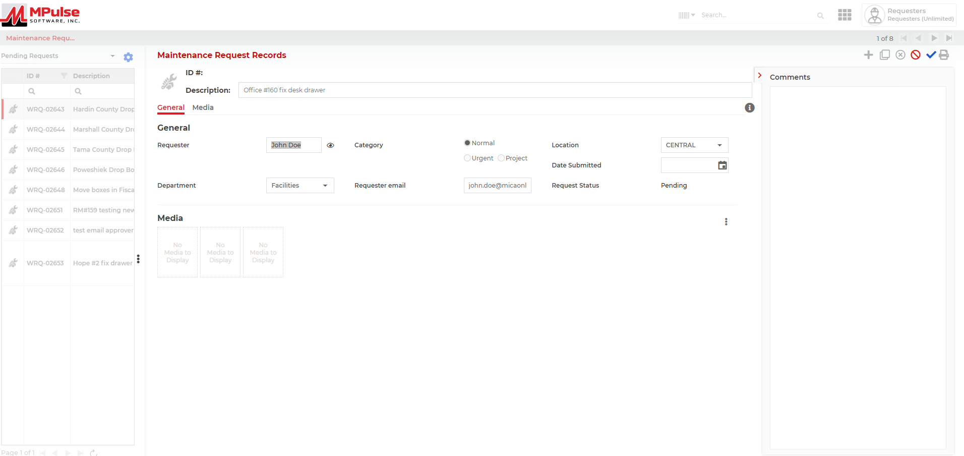

9. In Comments: Click in the comments box -Please describe the nature of your request with good detail. Better the information the better we are prepared when we come to complete the work order. Be as descriptive as possible! ☺ **This is new comments are one the right hand side of one screen now – not on the bottom ☺

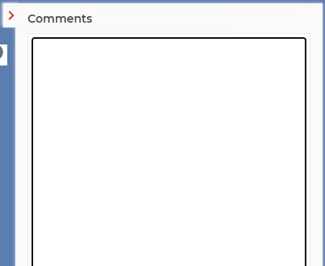



**Sites that are **owned** by MICA you will notice outside on the door frame a number of the offices including teacher offices, office hallways (like Central), common walking hallways, classrooms, storage rooms, mechanical rooms (where furnaces and/or water heaters are in), bathrooms, kitchens, copy rooms, waiting areas, basement area (MCFD), warehouse areas (Central, PCFD), will have a number outside the doorway or hallway. **You will be required to include the new room number in this description. Have to be as descriptive as possible in your request of what needs to be done. If you do not it will be sent back to you requesting more information and this will delay your request becoming a work order.** Example: Office #160- my desk drawer needs fixed, screw have fall out of track now will not stay in or closed. I have the screws (or if lost tell us you do not have the screws).

These sites are:

**Marshalltown**: Central Office, High Street Head Start, Marshall County Family Development Office

**Tama**: Tama County Family Development and Head Start

**Grinnell**: Poweshiek County Family Development

**Iowa Falls**: Hardin County Family Development and Head Start

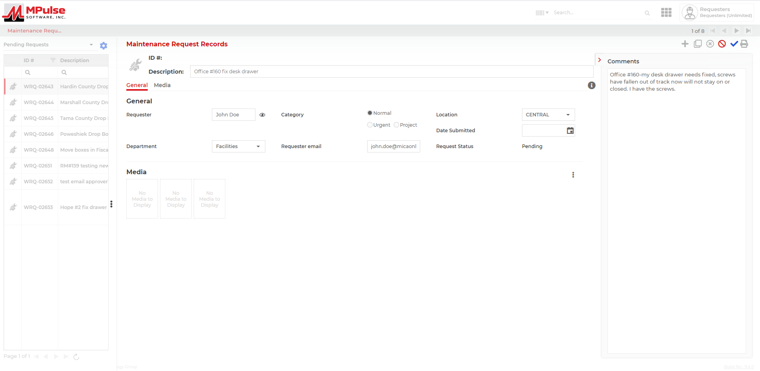



Sites that are not owned by MICA will not have numbers outside of doorway posted. You will need to identify what room and where at.

These sites are:

**Marshalltown**: Head Start Classrooms located in First United Methodist Church, Hope United Methodist Church

**Nevada**: Nevada Head Start Classroom located in the Nevada Community Resource Center

**Ames**: Story County Family Development, Story County Health Services -

**You will be required to state location of office, who is in the office, if multiple bathrooms will have to be descriptive of location in this description, if more than one classroom will have to tell us which classroom. Have to be as descriptive as possible in your request of what needs to be done. If you do not it will be sent back to you requesting more information and this will delay your request becoming a work order**. Example: Hope #2 Classroom – my desk drawer needs fixed, screws have fallen out of track now will not stay on or closed. I have the screws (or if lost tell us you do not have the screws).



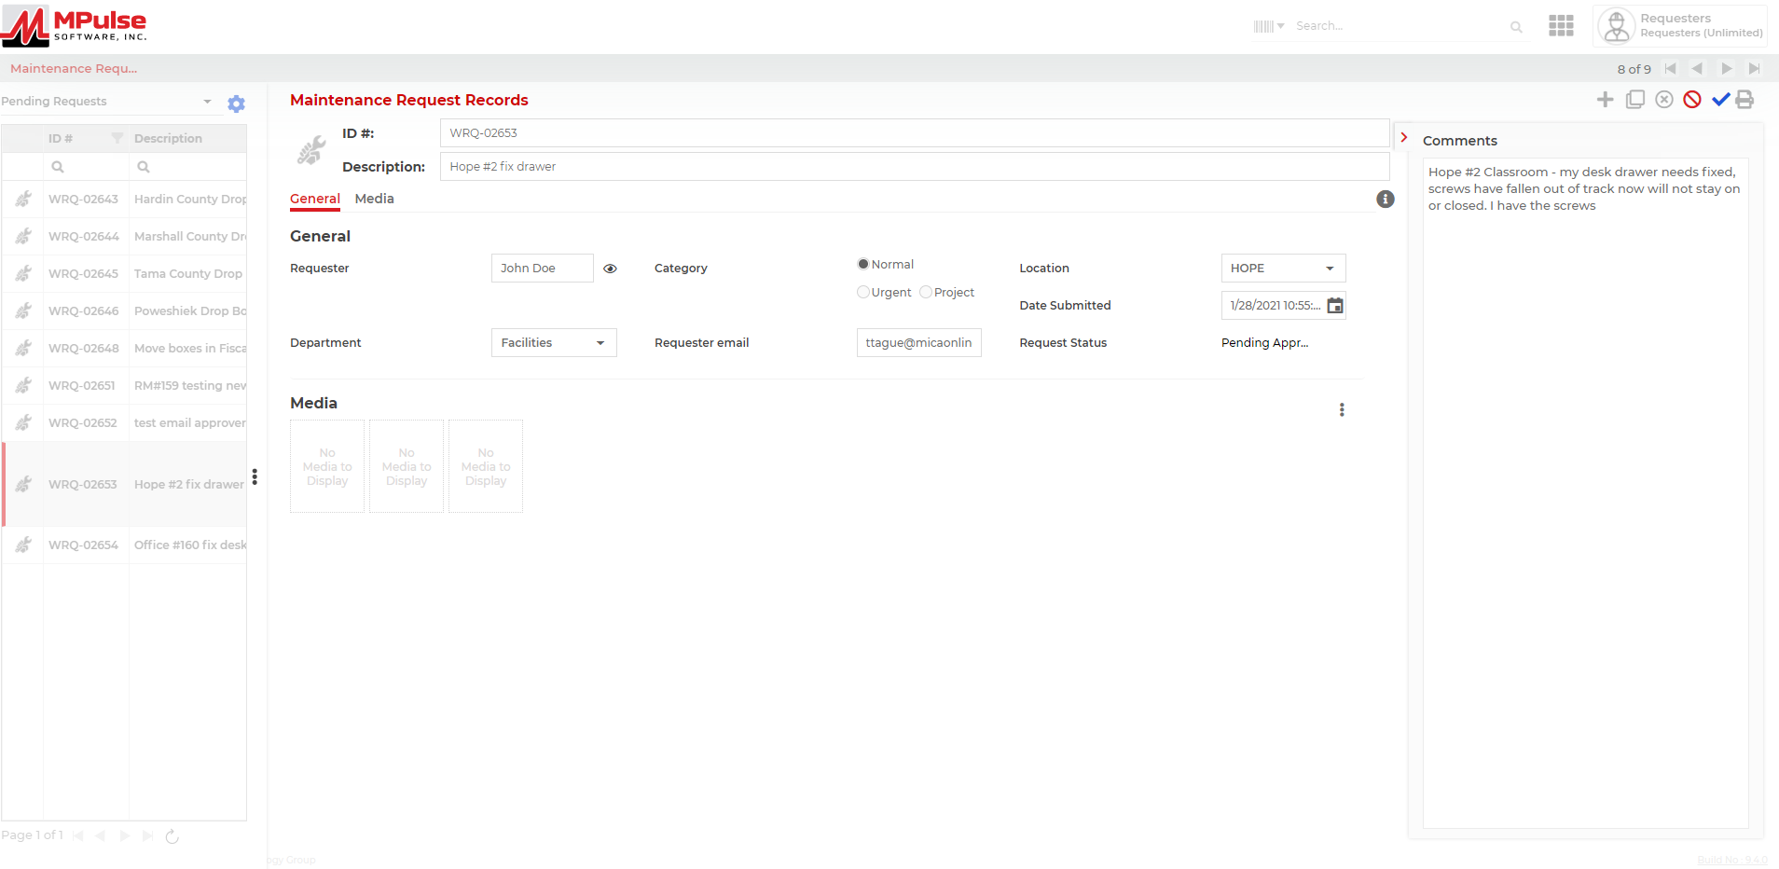



10. Review your request for accurate information **before** click the save icon. 

VERY IMPORTANT CLICK SAVE BUTTON BEFORE YOU LOG OUT – IF YOU DO NOT THE NEXT PERSON

WILL BE UNABLE TO DO A REQUEST



11. In the Submitted is Successful popup click OK. 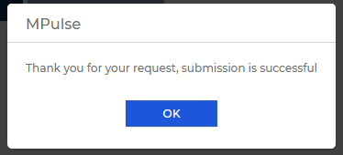

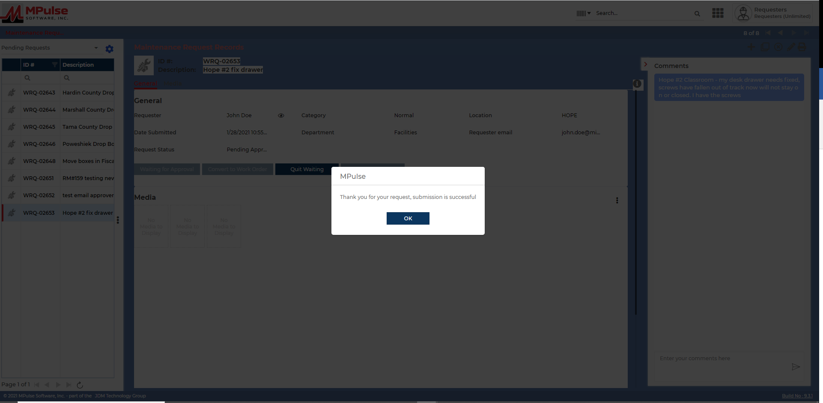



12. How to logout, (Do not just close your web browser) this is a two icon process on the left side of screen:

A. Go to upper right side of screen locate this icon:  click on it

B. When it opens you will see Logout click on Logout

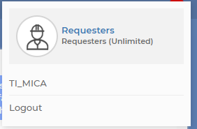



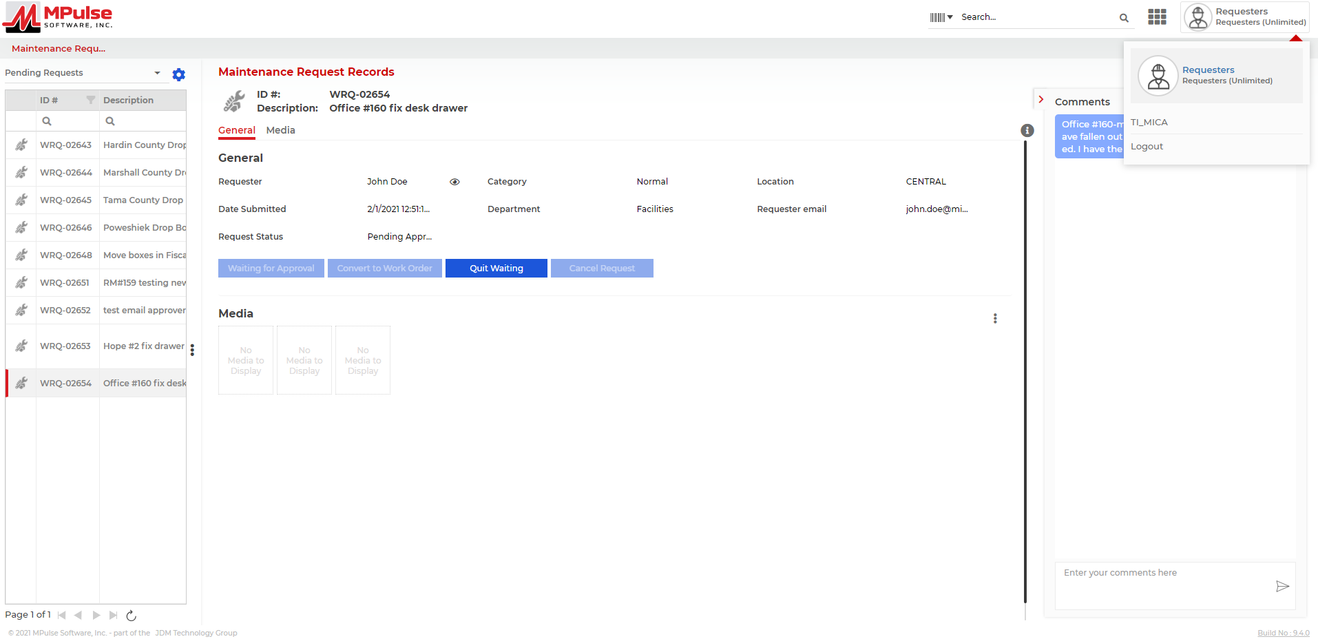



C. Once you click on Logout you will return to the login screen:

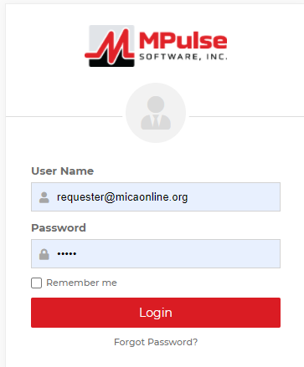



You will receive an email that confirms the request has been submitted. The person that is required to approve the request will get an email notifying them that there is a work order request they need to approve. You can log back in and check the status of the work request by using the table to the left. Look up your work order and where it says Request Status if it says pending approval still it has not been approved yet, if it says approved then it has not been converted to a work order, if it says converted or no longer is there it has been converted to a work order and is in the system to be assigned to be completed.



**Editing or Adding to Comments**

****If there is not enough information then you may receive an email that says “not enough information” please use link or if you get an email from your approver you will need to log back in.



Log back into MPulse9 (User Name = requester@micaonline.org, Password = happy, then hit 

Go to your work order from the list on the left and click on it or if it is still showing on screen you need to begin with directions below.

**Editing:**

1. If you need to edit Requester, Location, Department, Requester Email you will need to click on  in the upper right hand corner of request.



1. When done click on  (this toolbar will be in upper right corner after you have clicked the pencil).



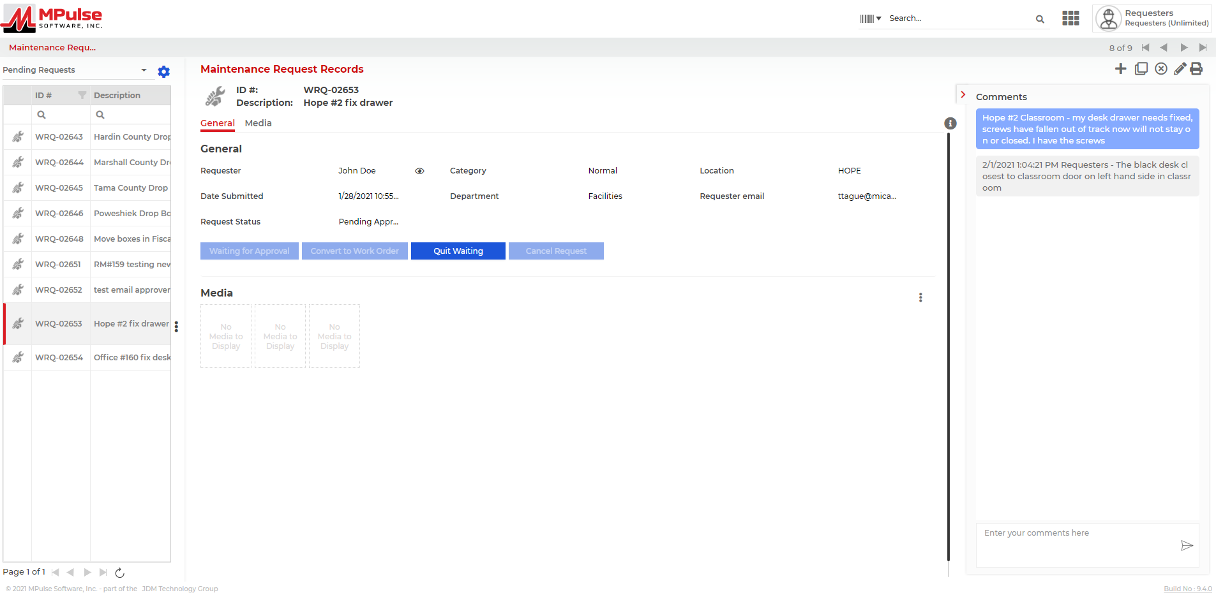



**Adding to Comments: (you do not have to click on the pencil to add)**

1. If you need to Add to comments you only need to click in this box located at bottom of comments box:

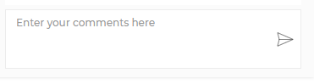

Be as descriptive as possible add what is requested.

1. When completed click the  and your additional information will be added to the work order request.





**You will need to email back to the person that the work order was updated so the approver can approve the work order.